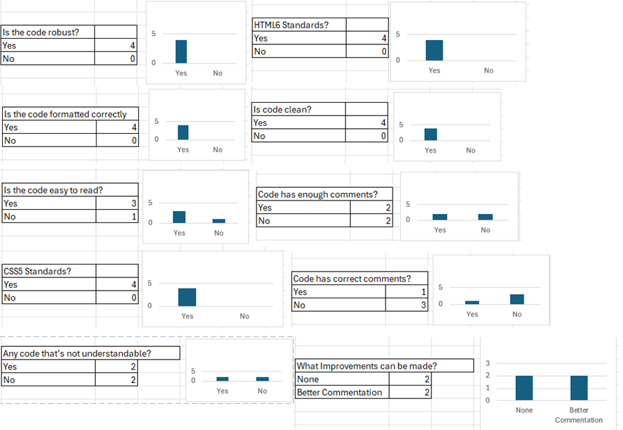
Feedback from multiple users shows that many people are happy with the code. On some questions 100% of participants stated the code is robust, clean, and follows all HTML and CSS standards. A small percentage of participants said the code was not easy to read, and half the participants said there is pieces of code that is not understandable, meaning code must be reviewed to check for structure and messy sections.
While the system has positives such as following coding standards, a big number of participants said the code does not have enough comments and doesn’t have the correct comments. Users said the code requires better commendations, which would in fact make the code easier to read.

